1. Write a Program to traverse or iterate ArrayList

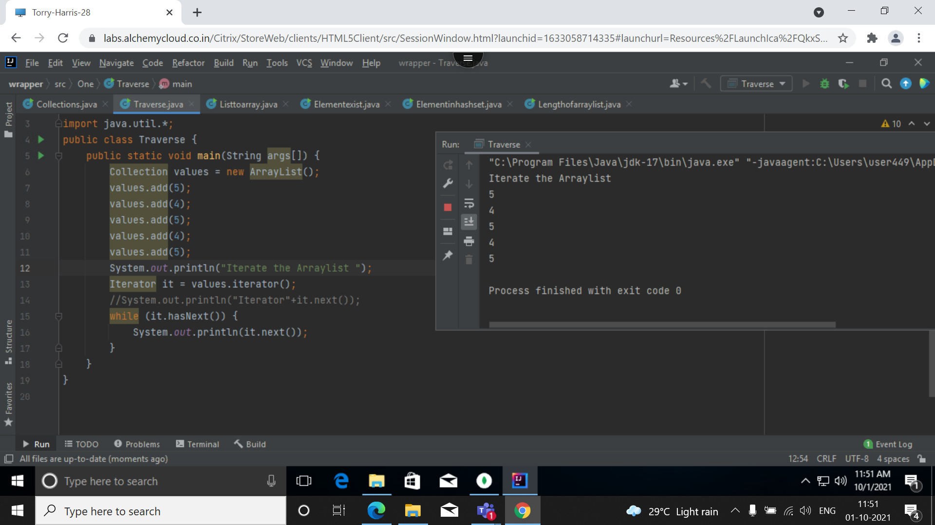

2. Write a program to check if element exists in ArrayList

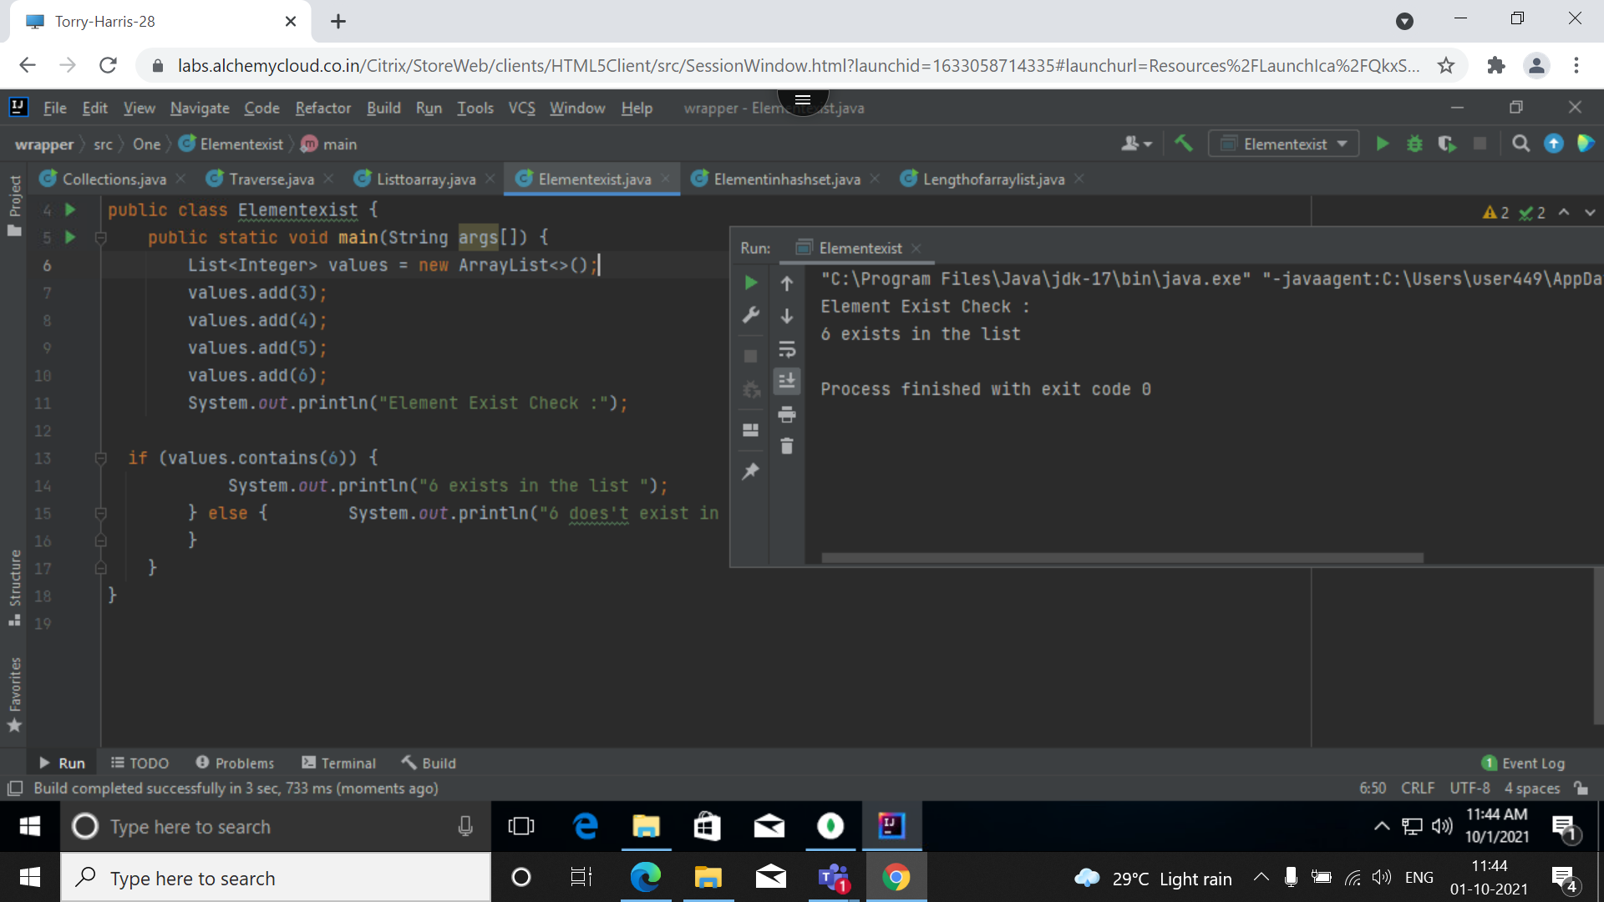

3. Given an element write a program to check if element exits in HashSet

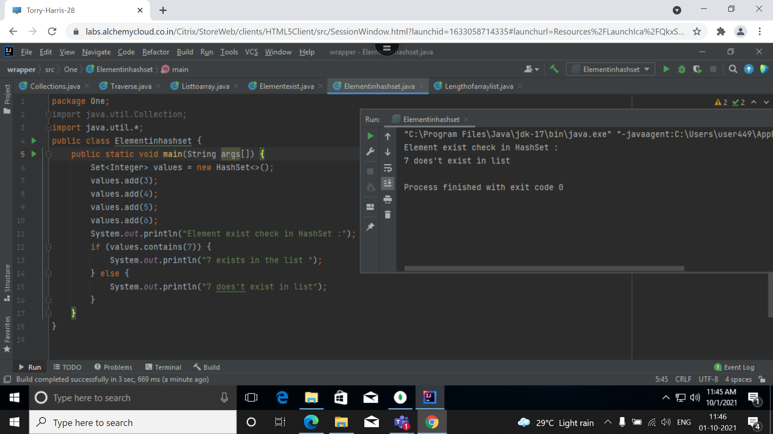

4. WAP to find Length of ArrayList

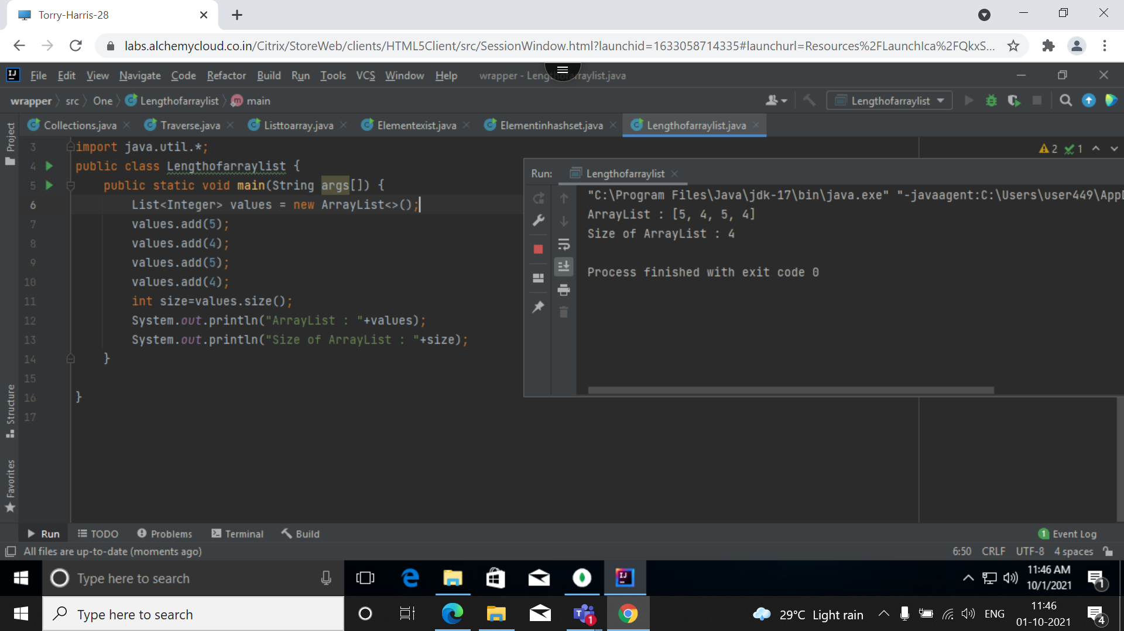

5. WAP to convert List to Array

